To Create Table:
Use Employees;
CREATE TABLE Job (
JobCode INT PRIMARY KEY,
[Description] VARCHAR(25),
RayRate Numeric(4,2)
);

CREATE TABLE Employee (
EmpID INT PRIMARY KEY,
SIN INT NOT NULL UNIQUE,
LastName VARCHAR(25) NOT NULL,
FirstName VARCHAR(25),
Street VARCHAR(30),
City VARCHAR(25),
Province CHAR(2),
PostalCode VARCHAR(7),
JobCode INT,
IncomeTax CHAR(1),
BirthDate DATE,
HireDate DATE,
JobCodeDate DATE,
FOREIGN KEY (JobCode) REFERENCES Job(JobCode)
);

CREATE TABLE Timesheet (
EmpID INT,
PayWeekEndDate DATE,
RegHours INT,
OTimeHours NUMERIC(5,2),
PRIMARY KEY (EmpID, PayWeekEndDate),
FOREIGN KEY (EmpID) REFERENCES Employee(EmpID)
);
--The tables must be created in this order due to referential integrity or dependency.
--Job Table must be created first because Employee contains a Foreign Key (JobCode) that references it.
--Employee must be created before Timesheet because the Timesheet table uses EmpID as a Foreign Key to link to the Employee table.
--We must create Job table first to use it JobCode fields as a Foreign Key for Employee Table and then We will create Employee Table
--because Timesheet table will reference EmpID Field from Employee.

-- 2. INSERT DATA INTO JOBS
INSERT INTO Job (JobCode, [Description], RayRate)
VALUES
(1000, 'Manager', 32.4),
(2000, 'Cashier', 11.63),
(3000, 'Stockperson', 8.89),
(4000, 'Baker', 18.91),
(5000, 'Butcher', 19.26),
(6000, 'Cleaner', 6.75),
(7000, 'Pharmacist', 28.17),
(8000, 'Assistant Baker', 12.58);

--INSERT DATA INTO EMPLOYEES
INSERT INTO Employee (EmpID, SIN, LastName, FirstName, Street, City, Province, PostalCode, JobCode, IncomeTax, BirthDate, HireDate, JobCodeDate)
VALUES
(97319, 516303417, 'Novak', 'Gerry', '6803 Park Ave.', 'Moose Jaw', 'SK', 'S6H 1X7', 3000, 'N', '1986-08-24', '2003-07-07', '2003-07-07'),
(33982, 867481381, 'Boychuk', 'Robin', '117 East Broadway', 'Moose Jaw', 'SK', 'S6H 3P5', 5000, 'Y', '1971-03-04', '1998-10-11', '1998-10-11'),
(51537, 112893584, 'Smith', 'Kim', '9745 University Drive', 'Regina', 'SK', 'S4P 7A3', 2000, 'Y', '1982-11-29', '2001-12-02', '2001-12-02'),
(41822, 717505366, 'Miller', 'Chris', '72 Railway Ave.', 'Pense', 'SK', 'S0T 1K4', 2000, 'Y', '1968-11-15', '1985-02-19', '1985-02-19'),
(3571, 374853129, 'Hashimoto', 'Jo', '386 High Street', 'Tuxford', 'SK', 'S0L 8V6', 1000, 'Y', '1956-06-23', '1980-03-20', '1999-08-30'),
(85833, 466128562, 'Singh', 'Lindsey', '1216 Willow Cres.', 'Pasqua', 'SK', 'S0H 5T8', 7000, 'Y', '1975-03-15', '2002-07-27', '2002-07-27'),
(81216, 615917448, 'Hansen', 'Jaimie', '95 Lakeshore Blvd.', 'Caronport', 'SK', 'S0T 3S7', 8000, 'Y', '1983-03-04', '2002-05-21', '2002-05-21'),
(32177, 306114858, 'DaSilva', 'Robbie', '4319 Main St.', 'Moose Jaw', 'SK', 'S6H 2M2', 4000, 'Y', '1951-02-18', '1983-07-07', '1992-09-15'),
(52421, 936654021, 'O''Day', 'Ashley', '27 High St.', 'Tuxford', 'SK', 'S0L 8V6', 6000, 'Y', '1963-07-31', '1997-11-08', '1997-11-08'),
(72690, 655971502, 'Wong', 'Jodie', '59 Oslo Square', 'Moose Jaw', 'SK', 'S6H 2H9', 6000, 'N', '1987-01-01', '2003-08-26', '2003-08-26'),
(72201, 635111876, 'Ramirez', 'Kelly', '1015 Brunswick Lane', 'Moose Jaw', 'SK', 'S6H 4T5', 3000, 'N', '1986-09-29', '2003-08-26', '2003-08-26');

--INSERT DATA VALUES INTO TIMESHEETS
INSERT INTO Timesheet (EmpID, PayWeekEndDate, RegHours, OTimeHours)
VALUES
(72690, '2003-05-23', 36, 0.00),
(52421, '2003-05-23', 22, 0.00),
(85833, '2003-05-23', 37.5, 0.50),
(81216, '2003-05-23', 40, 0.00),
(33982, '2003-05-23', 40, 0.00),
(32177, '2003-05-23', 40, 3.75),
(51537, '2003-05-23', 27, 0.00),
(41822, '2003-05-23', 40, 0.00),
(3571, '2003-05-23', 40, 0.00),
(72201, '2003-05-30', 18, 0.00),
(52421, '2003-05-30', 40, 4.50),
(85833, '2003-05-30', 22, 0.00),
(33982, '2003-05-30', 38.25, 0.00),
(32177, '2003-05-30', 40, 2.25),
(41822, '2003-05-30', 38, 1.25),
(3571, '2003-05-30', 40, 0.00);
Question.4-6
USE Employees
--Step 1: Insert the new Job record into the Job table first.
--This ensures JobCode 88 exists before we try to assign it to employees.

INSERT INTO Job (JobCode, [Description], RayRate)
VALUES (88, 'Instructor', 25.50);

--Step 2: Update the Employee table to change the code.
--Change the JobCode from 20 to 88 for all affected employees.
-- it will find out every JobCode has value 20 in it then will replace the value with 88
UPDATE Employee
SET JobCode = 88
WHERE JobCode = 20;

--Step 3: Remove the old Job record.
--Now that no employees are linked to JobCode 20, as we replace this code by 88, and this code can be safely deleted.
DELETE FROM Job
WHERE JobCode = 20;
Question: 7
USE Employees
-- Attempting to delete employee 32177
DELETE FROM Employee
WHERE EmpID = 32177;

/*The execution failed and returned a Foreign Key constraint error (likely a "Reference Constraint" violation).

The record was not deleted. The Timesheet table contains records associated with EmpID 32177.
In the database schema, the EmpID in the Timesheet table is a Foreign Key that references the Employee table.
SQL Server enforces referential integrity. This prevents you from deleting a parent record (Employee) if child records (Timesheets)
still exist, as those timesheets would become "orphaned" with no valid employee to point to.*/

Question 8: USE Employees
DELETE FROM Employee
WHERE EmpID = 1350;--This Id does not exist.

/* When trying to delete a non-existent employee ID like 1350,
the SQL statement DOES execute properly.
*/

- Query To show Employee Table
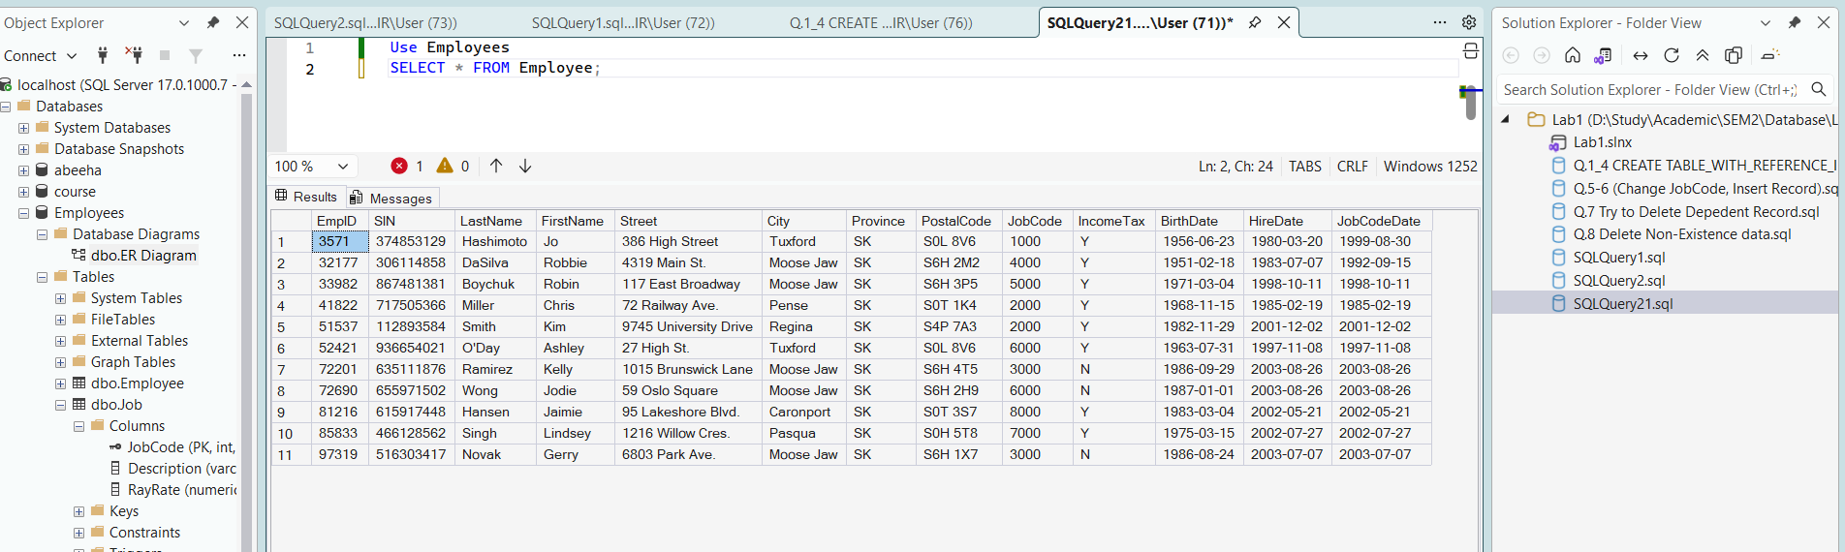
- Query to show Employee.
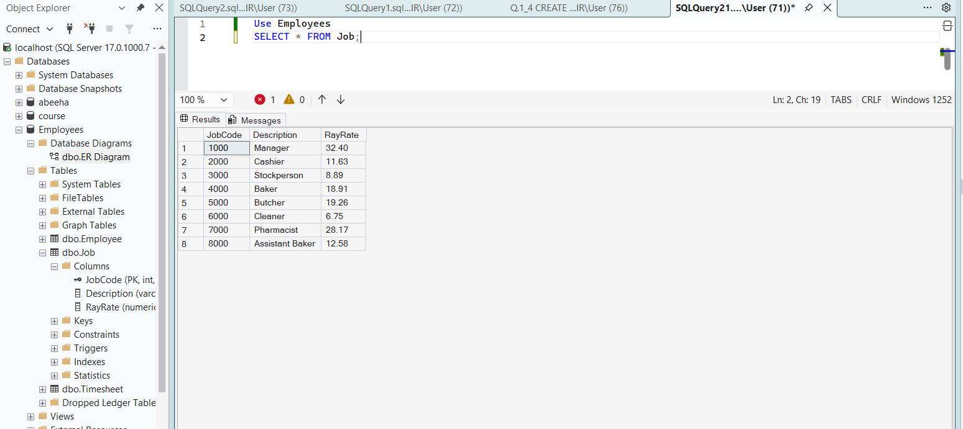
3. Query to show Timesheet.
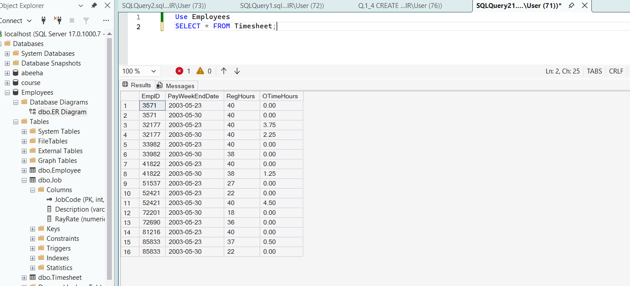
ER Diagram for total Employees Database
